## Design Thinking Project Workbook

**Don't find customers for your product but find products for your customers**

# 1. Team

**Team Name:**

PathFinders

**Team Logo (if any):**



**Team Members:**

1. [**P.Phani Tejaswi**, Team Leader and Ideate**,** 8333965338]
2. [**G.Lavanya Reddy**, Researched on Needs and Insights of Users,9949979757]
3. [**B.Sri Krishna**, Identifying Project Challenges & Code Debugger, 9603950078]

# Problem/Opportunity Domain

## Domain of Interest:

Travel Planner

## Description of the Domain:

The travel planning domain focuses on organizing trips, itineraries, and related travel logistics for individuals or groups. This can include booking transportation, accommodations, activities, and providing suggestions for tourist destinations, restaurants, and local experiences.

## Why did you choose this domain?

1. **Growing Demand:** With the rise of global travel, people are constantly looking for easy and convenient ways to plan their trips, making this domain highly relevant.
2. **Innovation Opportunities:** There is room to introduce new features, such as AI-driven personalized itineraries, cost optimization, and real-time updates for travelers.
3. **Problem Solving:** The domain addresses common pain points like handling complex logistics, finding the best deals, and optimizing travel plans, providing a valuable service to users.
4. **Technological Integration:** This domain allows for the integration of various technologies such as GPS, mapping services, and online booking platforms to create a seamless user experience.
5. **Personal Interest:** If you have a passion for travel, working in this domain can be both fulfilling and engaging.

# Problem/Opportunity Statement

## Problem Statement: Travelers face challenges in organizing and optimizing their travel plans, such as creating detailed itineraries, selecting destinations, and managing bookings across multiple platforms. An AI-powered travel planner can streamline the process by providing personalized, automated, and real-time solutions.

## Problem Description: Travel planning is often complex, requiring travelers to sift through numerous websites for booking flights, hotels, and activities. They must also consider factors such as budget, preferences, availability, and time constraints. The manual process can lead to suboptimal travel experiences, missed opportunities, and wasted time. A travel planner utilizing Artificial Intelligence and Machine Learning (AI/ML) can help automate itinerary generation, provide real-time suggestions, and offer cost-saving insights based on user preferences and historical data.

## Context (When does the problem occur):

* When travellers start planning a trip and need to consolidate information from various sources (e.g., flights, accommodations, activities).
* When changes in plans occur due to cancellations, delays, or other unexpected events.
* When users lack knowledge about their destination or struggle to create an optimized itinerary.
* When travellers are on a budget or time constraint and need to find the best deals or efficient travel routes.

**Alternatives (What does the customer do to fix the problem):**

Use multiple travel websites or apps (e.g., Google Flights, Expedia, Airbnb, TripAdvisor) to manually

gather and compare information.

Consult travel agents for assistance.

• Rely on personal research, reviews, and recommendations from social media or friends.

• Use spreadsheets or travel planning apps to organize trips but with limited automation.

## Customers (Who has the problem most often):

• Frequent **Travelers:** Business travellers and frequent flyers who need efficient, time-saving solutions.

• Leisure **Travelers:** Individuals or families planning vacations and looking for personalized, cost-

effective itineraries..

• Budget **Travelers:** Travelers who prioritize finding the best deals and maximizing their experiences

within a limited budget.

• Adventurers**:** Travelers seeking off-the-beaten-path destinations or experiences, often

Needing more in-depth research and planning.

## Emotional Impact (How does the customer feel):

• **Frustration:** Due to the overwhelming number of options and the complexity of comparing them.

• **Stress/Anxiety:** From the uncertainty of choosing the best options or dealing with last-minute changes or

cancellations.

• **Disappointment:** When travel experiences don’t meet expectations due to poor planning or missing important

opportunities.

## •**Relief/Excitement:** When a solution helps streamline the process, providing an efficient and enjoyable travel experience.

## Quantifiable Impact (What is the measurable impact):

• **Time Saved:** AI/ML solutions can reduce the time spent on travel planning by automating itinerary

generation and suggesting optimal routes.

• **Cost Efficiency:** By analyzing price trends and deals, AI-driven tools can help travelers save money on

bookings, transportation, and accommodations.

• **Increased Customer Satisfaction:** Improved, personalized travel experiences result in higher

satisfaction rates, leading to repeat customers.

• **Reduced Cancellations/Delays:** AI/ML systems can offer real-time updates on potential disruptions and

suggest alternatives to minimize impact on travel plans

**Alternative Shortcomings (What are the disadvantages of the alternatives):**

The current alternatives for travel planning, such as using multiple travel websites or consulting travel agents, come with significant drawbacks. Manual travel websites require travelers to invest a lot of time searching and comparing options across fragmented platforms, leading to inefficiencies and missed opportunities. These platforms also lack personalization, offering generic suggestions that don’t cater to individual preferences or budgets. Travel agents, while offering expertise, can be expensive and limit flexibility, as travelers rely on the agent’s suggestions, which may not fully meet their needs. Both options lack real-time adaptability, making it hard to adjust plans on the go.

**Any Video or Images to showcase the problem:**





# Addressing SDGs

## Relevant Sustainable Development Goals (SDGs)

**SDG 8: Decent Work and Economic Growth**

Promotes sustainable tourism, which creates jobs and supports local economies, particularly in developing regions. AI/ML can recommend eco-friendly accommodations and activities that benefit local communities.

**SDG 9: Industry, Innovation, and Infrastructure**

Enhances travel infrastructure by incorporating smart technology, encouraging innovation in the tourism

sector, and optimizing travel routes and resources.

**SDG 11: Sustainable Cities and Communities**

Encourages responsible and sustainable tourism by promoting lesser-known destinations, reducing overtourism in popular cities, and supporting local cultures and heritage.

# How does your problem/opportunity address these SDGs?

**SDG 8: Decent Work and Economic Growth**

Promotes sustainable tourism, which creates jobs and supports local economies, particularly in developing regions. AI/ML can recommend eco-friendly accommodations and activities that benefit local communities.

**SDG 9: Industry, Innovation, and Infrastructure**

Enhances travel infrastructure by incorporating smart technology, encouraging innovation in the tourism sector, and optimizing travel routes and resources.

**SDG 11: Sustainable Cities and Communities**

Encourages responsible and sustainable tourism by promoting lesser-known destinations, reducing over tourism in popular cities, and supporting local cultures and heritage.

**SDG 12: Responsible Consumption and Production**

AI/ML travel planners can help travellers make sustainable choices by recommending eco-friendly transportation options (e.g., trains over flights), sustainable accommodations, and minimizing environmental impact through efficient travel planning.

# Stakeholders

### Answer these below questions to understand the stakeholder related to your project

1. **Who are the key stakeholders involved in or affected by this project?**

The key stakeholders in the AI/ML travel planner project include travellers (end users), travel agencies, tourism boards, local communities, transportation and accommodation providers (e.g., airlines, hotels), tech developers and AI/ML engineers, environmental and sustainability organizations, and government/regulatory bodies. Each of these stakeholders has an important role in shaping the platform’s features, functionality, sustainability focus, and overall user experience in the travel planning process.

### What roles do the stakeholders play in the success of the innovation?

### Travelers are central to the platform’s success, providing data and feedback to refine personalization features. Travel agencies can integrate services, increasing reach. Tourism boards promote destinations and forge partnerships. Transport and accommodation providers ensure real-time booking options. Tech developers and AI/ML engineers create and maintain the system. Environmental organizations ensure sustainability. Government bodies regulate policies and ensure compliance, further shaping the platform’s success.

### What are the main interests and concerns of each stakeholder?

Travelers seek convenience, cost savings, and personalized experiences. Travel agencies aim to expand their services through the platform. Tourism boards are interested in promoting local attractions and managing tourism sustainably. Transport and accommodation providers focus on maximizing bookings. Tech developers aim to ensure system reliability and innovation. Environmental groups are concerned about reducing the travel sector's carbon footprint. Government bodies focus on regulation, safety, and data privacy compliance.

**4. How much influence does each stakeholder have on the outcome of the project?**

Travelers hold high influence as their adoption drives platform success. Travel agencies and transport/accommodation providers have significant influence through service integration and partnerships. Tourism boards and local communities shape content and recommendations. Tech developers have direct influence by ensuring the platform functions optimally.

### 5.What is the level of engagement or support expected from each stakeholder?

### Travelers are expected to actively engage through feedback and platform usage. Travel agencies and providers are anticipated to support by integrating their services. Tourism boards and local communities are likely to engage by offering partnerships and promoting destinations.

### 6. Are there any conflicts of interest between stakeholders? If so, how can they be addressed?

Conflicts of interest may arise between stakeholders in the AI/ML travel planner. Travelers seek cost-effective options, while providers focus on profits. Environmental organizations advocate for sustainability, potentially conflicting with profit-driven agencies. Addressing these conflicts requires transparent pricing, promoting eco-friendly alternatives, and balancing popular and emerging destinations to satisfy all parties.

### 7. How will you communicate and collaborate with stakeholders throughout the project?

Effective communication and collaboration with stakeholders in the AI/ML travel planner project will involve regular updates through meetings, surveys, and feedback sessions. Utilizing collaborative tools like project management software and shared platforms will ensure transparency, encourage stakeholder input, and foster a sense of partnership, aligning interests and enhancing the project’s success.

### 8. What potential risks do stakeholders bring to the project, and how can these be mitigated?

Stakeholders may introduce risks such as resistance to change from travel agencies, data privacy concerns from travelers, and sustainability compliance issues from providers. Mitigation strategies include providing training for agencies, implementing robust data protection measures, and engaging environmental organizations to ensure adherence to sustainability standards throughout the project.

# Power Interest Matrix of Stakeholders

**Power Interest Matrix: Provide a diagrammatic representation of Power Interest Matrix**

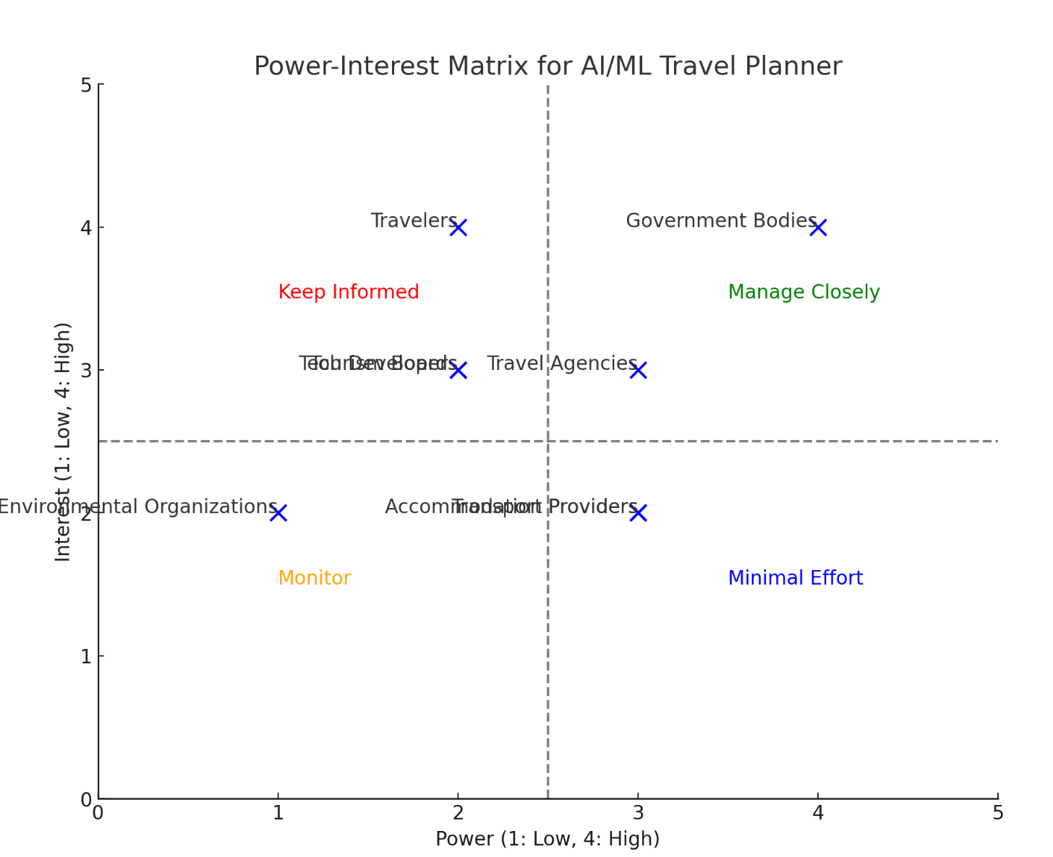

* **Manage Closely:** Stakeholders like Travel Agencies, Transport Providers, and Accommodation Providers have high power and interest, requiring focused management and engagement.
* **Keep Informed:** Stakeholders such as Travelers and Government Bodies have high interest but lower power; they should be kept informed and engaged.
* **Monitor:** Stakeholders like Environmental Organizations and Tourism Boards have moderate interest and lower power, so monitoring their concerns is essential.
* **Minimal Effort:** Stakeholders with low interest and power require minimal engagement but should still be kept in the loop as needed.

# Empathetic Interviews

### Conduct Skilled interview with at least 30 citizens/Users by asking open ended questions (What, why/How etc) and list the insights as per the format below

|  |  |  |
| --- | --- | --- |
| **I need to know (thoughts, feelings,**  **actions)** | **Questions I will ask (open questions)** | **Insights I hope to gain** |
| Thoughts | What are your thoughts on using AI for travel planning? | Whether users trust AI-powered travel recommendations. |
|  | How do you decide on your travel destinations? | What criteria users consider when selecting travel spots. |
| Feelings | How does it make you feel when travel recommendations align with your preferences? | Users’ emotional responses to personalized suggestions. |
|  | How do you feel about the idea of AI adapting to your travel preferences over time? | Users' comfort level with evolving recommendations. |
| Actions | How do you typically use travel planning apps? | Understanding common workflows and interactions with tools. |
|  | How do you manage bookings and itineraries provided by the app? | Whether users take manual steps to modify suggested plans. |

**SKILLED INTERVIEW REPORT**

**(Examples are given. Erase them and fill with your user information.)**

|  |  |  |
| --- | --- | --- |
| **User/Interviewee** | **Questions Asked** | **Insights gained (NOT THEIR ANSWERS)** |
| Ravi,Frequent Traveler | What are your thoughts on using AI for travel planning? | Some users are concerned about the reliability of AI-generated travel recommendations. |
| Priya, Student | How do you decide on your travel destinations? | Users prioritize personal interests, budget, and recommendations from friends when choosing destinations. |
| Arjun, Student | How do you use travel planning apps during your trips? | Users often rely on apps for real-time updates but prefer printed itineraries for convenience. |
| Spandana, Lecturer | How do you handle changes to your travel itinerary suggested by the app? | Some users prefer to manually adjust their itineraries instead of relying solely on AI suggestions. |

**Key Insights Gained:**

Key insights gained include the importance of personalized travel recommendations to enhance user satisfaction and the need for users to maintain control over their itineraries, as they often prefer to manually adjust AI-generated suggestions

# Empathy Map

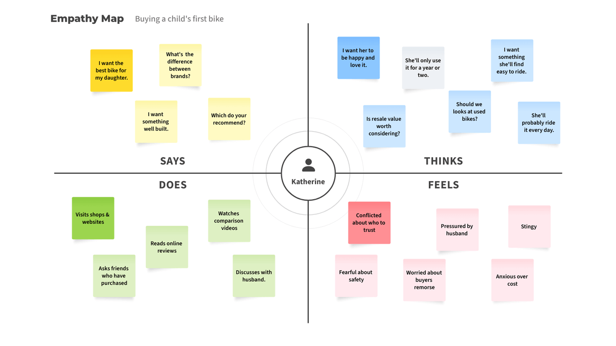

* + 1. **Empathy Map**

1. **Who is your customer?**

**Customer Profile:**

* + **Age:** 25-45 years old
  + **Profession:** Young professionals, digital nomads, families, and frequent travelers.
  + **Interests:** Travel, adventure, cultural experiences, eco-friendly tourism, local cuisine, and technology.

**Goals and Needs:**

To discover personalized travel destinations and experiences that align with their interests.

**Context:**

Reliable and relevant travel suggestions tailored to personal preferences.

1. **Who are we empathizing with?**

**User Characteristics:**

* + **Personality:** Curious and adventurous, open to new experiences
  + **Values:** Values sustainability and eco-friendly travel options.
  + **Responsibilities: Goals and Challenges:**
* **Goal:** • To create memorable and enjoyable travel experiences that align with personal interests and values, while managing time and budget effectively.
  + **Challenge:** Overwhelmed by the vast amount of information and options available for travel planning, leading to decision fatigue.
  + **Broader Situation:** Users often feel pressure from societal expectations to travel to popular destinations while also wanting to explore unique and less commercialized locations.

1. **What do they need to DO?**

**Tasks and Actions:**

* **Research:**

Explore potential travel destinations, activities, and accommodations based on personal preferences and interests.

* **Plan:**

Create and organize itineraries that include transportation, lodging, and activities, ensuring a balance between structure and flexibility.

* **Book:**

Make reservations for flights, accommodations, and activities, ensuring the best deals and options.

**Decisions:**

Choose destinations based on factors like budget, interests, and travel time.

**Success Definition:**

Achieving enjoyable and fulfilling travel experiences that align with personal interests and values.

1. **What do they SEE?**

**Environment:**

* + - * Digital Landscape:
      * Local Culture:
      * T ravel Communities:

**Trends and Competitors:** There is a growing trend in using AI and machine learning for personalized travel planning, with competitors offering tailored recommendations based on user preferences and behavior.

**Influence of Visual Elements:**

Users are attracted to vibrant, high-quality images and videos of destinations and experiences, which significantly influence their decisions and spark their curiosity.

1. **What do they SAY?**

**Open Expressions:**

• "I wish I could find travel options that really match my interests."

• "Sometimes, I feel overwhelmed by all the choices available."

**Goals and Frustrations:**

• "I want to have memorable and personalized travel experiences."

• "I need a planner that helps me stay organized without adding stress to my planning process."

* + **Feedback:**

• "I love the idea of having an AI-powered travel planner, but I need it to learn my preferences better over time."

• "Real-time updates and notifications would make my travel planning much easier."

1. **What do they DO?**

**Observable Actions:**

Users actively search for travel information online, utilizing various platforms, apps, and social media to gather ideas and options for their trips.

**Habits and Routines:**

Many users set aside specific times each week to research potential travel destinations and activities, helping them stay organized and informed.

**Problem Solving:**

When faced with indecision or uncertainty, users turn to friends, family, or online travel communities for recommendations and advice to inform their choices.

1. **What do they HEAR?**

**From Peers and Mentors:** Friends and family often share their travel experiences, providing suggestions for destinations, accommodations, and activities that they found enjoyable or worthwhile.

**Media and Information Channels:**

Users consume content from travel bloggers and vloggers, gaining insights and inspiration through their personal stories, tips, and destination highlights.

**Strong Influencers:**

Influencers on social media platforms who showcase their travels often impact users’ perceptions and preferences, inspiring them to visit certain locations or try specific activities.

1. **What do they THINK and FEEL?**

**Fears and Anxieties:**

* +   Users often worry about making the wrong decisions regarding destinations, accommodations, or activities that may lead to a disappointing travel experience.

**Motivations and Desires:**

Users are motivated by the hope of creating lasting memories and experiences that align with their interests and passions.

**Alignment of Thoughts and Actions:**

Users may experience tension between wanting to embrace spontaneous travel and the structured approach needed for effective planning, leading to conflict in decision-making.

1. **Pains and Gains**

**Pains:**

• **Overwhelming Options:**Users often face an overload of travel choices, leading to decision fatigue and difficulty in narrowing down their options.

• **Time-Consuming Planning:**The process of researching, comparing, and booking travel can be tedious and time-consuming, causing frustration and stress.

• **Unreliable Information:**Encountering misleading reviews or outdated information can result in poor travel decisions, leading to dissatisfaction during the trip.

**Gains:**

• **Personalized Recommendations:**Users benefit from AI-driven suggestions tailored to their interests, helping them discover unique experiences that match their preferences.

• **Time Savings:**Efficient travel planning tools can streamline the research and booking process, saving users time and reducing stress.

• **Enhanced Experiences:**With curated options and insider tips, users can access hidden gems and authentic experiences that enrich their travel adventures.

# 8. Persona of Stakeholders

**Stakeholder Name:** Travel Enthusiast

### Demographics:

**Age:**25 -45y

**Gender: both male and female**

**Income:** moderate to high

**Location:** They are typically located in urban areas with easy access to transportation hubs and a wealth of travel resources, including major cities and regions known for tourism.

### Goals: Travel enthusiasts aim to explore new destinations, immerse themselves in diverse cultures, and create lasting memories with friends or family. They seek unique experiences that align with their personal interests, whether that's adventure, relaxation, or cultural enrichment. They often desire to learn about the world and broaden their horizons through travel.

### Challenges:

One of the primary challenges faced by travel enthusiasts is managing the overwhelming number of travel options available, which can lead to decision fatigue. Additionally, they often struggle with time constraints, balancing work and personal commitments while planning their trips. Budget considerations also present a challenge, as they seek quality experiences without overspending.

### Aspirations:

### Travel enthusiasts aspire to be well-traveled individuals with diverse experiences that enrich their lives. They hope to visit off-the-beaten-path destinations, engage with local cultures, and share their adventures with others. Many aspire to create travel content, whether through blogs, vlogs, or social media, to inspire fellow travelers.

### Needs:

To fulfill their travel aspirations, enthusiasts need personalized recommendations that reflect their unique preferences and interests. They also require tools that streamline the planning process, providing easy access to information, bookings, and itineraries. Community engagement and insights from fellow travelers are also essential to enhance their planning and experiences.

### Pain Points:

Travel enthusiasts often encounter pain points such as difficulty in finding reliable information and trustworthy reviews. They may experience frustration with generic travel recommendations that do not cater to their specific interests. Additionally, unexpected changes, such as flight cancellations or budget overruns, can lead to anxiety and stress during the planning process.

### Storytelling:

### Imagine Sarah, a 30-year-old marketing professional living in a bustling city. With a steady income, she dreams of traveling to new destinations each year. However, her busy work schedule often leaves her feeling overwhelmed by the sheer number of options available for travel planning. Sarah yearns for a tool that not only understands her travel preferences but also simplifies the planning process. She desires a personalized experience that allows her to explore unique locations while staying within her budget. Through AI-powered recommendations, Sarah hopes to uncover hidden gems and connect with fellow travelers who share her passion for exploration, transforming her travel aspirations into unforgettable adventures.

**Sample:**

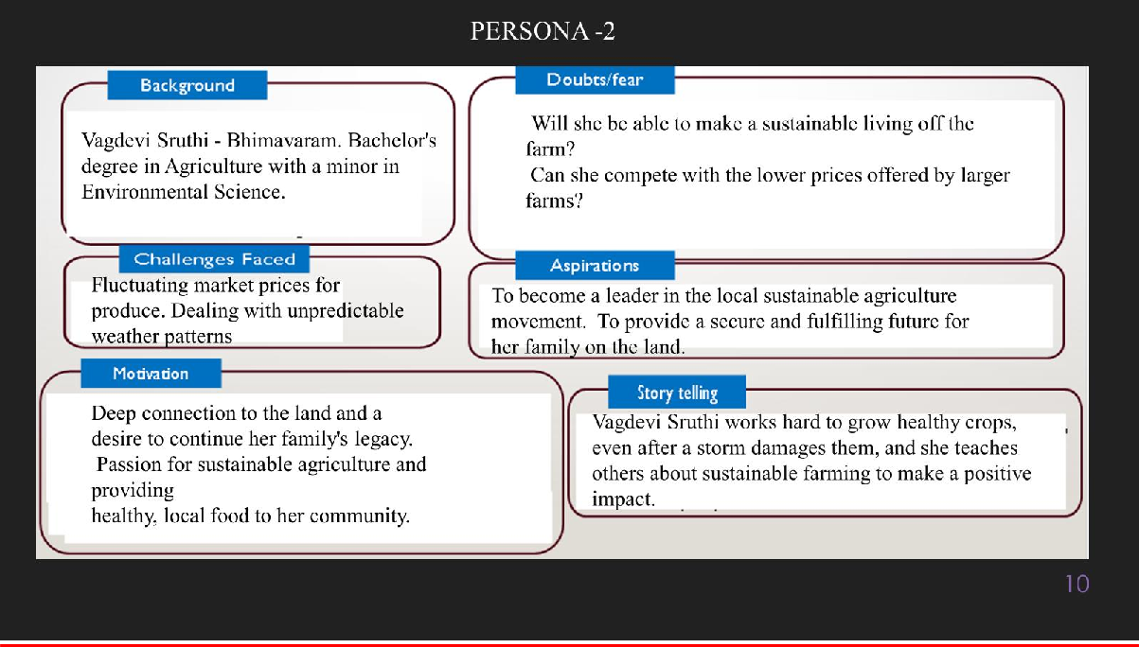

# 10. Look for Common Themes, Behaviors, Needs, and Pain Points among the Users

Analyse the data from your affinity diagram to uncover recurring patterns among your users, helping you better understand their expectations and challenges.

### Common Themes:

1. **Information Overload:** Users often feel overwhelmed by too many learning resources, making it hard to find what’s relevant quickly.
2. **Need for Accuracy:** Users want reliable and trustworthy information, especially in tech areas like AI and web development.

### Common Behaviors:

1. **Searching for Resources:** Users spend a lot of time looking for learning materials across different platforms due to information overload.
2. **Trial-and-Error Learning:** Many users try different resources to see what works best, which can be frustrating.
3. **Checking Credibility:** Users often verify information from multiple sources to ensure its accuracy.

### Common Needs:

1. **Reliable Information:** Users need accurate and trustworthy content to support their learning.
2. **User-Friendly Interface:** There’s a strong desire for an easy-to-navigate platform that reduces technical barriers.
3. **Quick Responses:** Users expect the Learning Assistant to provide fast and relevant answers to their questions.

### Common Pain Points:

1. **Feeling Overwhelmed:** Too much information makes it difficult to find useful resources, prolonging the learning process.
2. **Complex Designs:** Confusing interfaces can discourage users from fully engaging with the platform.
3. **Scepticism About Information:** Users worry about the reliability of the information they find, especially in important subjects.

# 12. Define Needs and Insights of Your Users

**User Needs:**

1. **Accurate Information:** Users require reliable and precise content, especially in areas like AI and web development, where incorrect information can lead to misunderstandings.
2. **User-Friendly Experience:** An intuitive interface is essential, allowing users to navigate the platform easily without technical difficulties.
3. **Personalized Learning Paths:** Users need tailored learning experiences that reflect their skills and interests, helping them progress at their own pace.
4. **Timely Responses:** Quick and relevant answers are crucial, as users want to minimize waiting time and enhance their learning efficiency.
5. **Progress Tracking:** Users desire clear milestones and visual indicators to help them see their achievements and stay motivated.

# User Insights:

1. **Frustration with Overload:** Users often feel overwhelmed by the abundance of resources available online, leading to difficulty in finding the most useful information.
2. **Desire for Control:** Many users prefer a system that allows them to choose their learning focus rather than following a rigid path, reflecting a need for autonomy in their learning journey.
3. **Cautious Decision-Making:** Users tend to verify information from multiple sources due to concerns about reliability, indicating a careful approach to learning.
4. **Time Constraints:** Users struggle to balance learning with full-time jobs, making efficiency a key priority in their learning experiences.
5. **Motivation through Milestones:** Clear progress tracking can significantly boost users' motivation and commitment, as seeing tangible achievements helps them stay engaged.

# POV Statements

**POV Statements:**

* [User] needs a way to [need] because [insight].

|  |  |  |  |
| --- | --- | --- | --- |
| **PoV Statements (At least ten)** | **Role- based or Situation- Based** | **Benefit, Way to Benefit,**  **Job TBD,**  **Need (more/less)** | **PoV Questions**  **(At least one per statement)** |
| Student needs a way to find reliable learning resources quickly because they often feel overwhelmed by the amount of information available online. | Situation | Way to Benefit | What can we design that helps students quickly find accurate resources? |
| Job seeker needs timely notifications about relevant courses and certifications because they want to enhance their skills to improve employability. | Situation | Way to Benefit | How can we ensure job seekers receive timely updates on learning opportunities that match their goals? |
| Placement candidate needs personalized learning paths because they want to learn at their own pace and focus on topics that will help them succeed in interviews. | Role- Based | Way to Benefit | What features can we implement to tailor learning paths for placement candidates? |
| Student needs progress tracking features because they want to monitor their achievements and stay motivated throughout their learning journey. | Situation | Benefit | What tools can we implement to help students visualize their learning progress? |
| Intern needs to verify information from multiple sources because they are cautious about the reliability of what they learn during their internship. | Role- Based | Way to Benefit | How can we provide verification tools to ensure the accuracy of information for interns? |
| A user wants to measure their learning progress because they are unsure if they are improving. | Situation | Way to Benefit | How can we design a feature that helps users measure and track their learning progress  ? |

|  |  |  |  |
| --- | --- | --- | --- |
| **PoV Statements (At least ten)** | Role- based or Situation- Based | Benefit, Way to Benefit,  Job TBD,  Need (more/less) | PoV Questions  (At least one per statement) |
| Tech enthusiast needs access to trending topics and resources because they want to stay informed about the latest advancements in technology. | Situation | Benefit | What can we create to help learners focus on specific technologies without feeling scattered? |
| Intern needs clear guidance on projects because they want to gain confidence and perform well in their role. | Situation | Benefit | How can we provide structured guidance to support interns in their tasks? |
| Learner needs access to skill-specific resources because they want to quickly improve their abilities in targeted areas | Role- Based | Way to Benefit | What can we design to provide learners with curated resources focused on specific skills they want to develop? |
| Course participant needs collaborative tools because they want to interact with peers and share knowledge effectively | Situation | Way to Benefit | What tools can we implement to enhance collaboration among course participants? |

* 1. **Develop POV/How Might We (HMW) Questions to Transform Insights/Needs into Opportunities for**

**Design**

Turn your user needs and insights into actionable opportunities by framing them as "How Might We" (HMW) questions. These questions will spark creative problem-solving and guide your innovation process.

### Task:

* **User Need:** "Learners need personalized learning paths to enhance their engagement."

**HMW Question:** "How might we develop a system that creates customized learning paths based on individual skills and interests?"

* **Insight:** "Users struggle with information overload when searching for resources."

**HMW Question:** "How might we design a streamlined resource retrieval system that minimizes information overload?"

* **User Need:** "Professionals need timely notifications about relevant courses." **HMW Question:** "How might we create an alert system that sends personalized course recommendations in real-time?"
* **Insight:** "Users often seek reliable information but are skeptical about sources."

**HMW Question:** "How might we build a verification feature that ensures users receive trustworthy information in critical areas?"

|  |  |
| --- | --- |
| **User Need/Insight** | **"How Might We" Question** |
| 1. **Users feel overwhelmed by the abundance of learning resources available.** 2. **Users want to stay consistent with their learning but struggle to remember tasks and deadlines.** 3. **Users need personalized learning paths tailored to their interests and skill levels.** 4. **Users are unsure which skills are trending and in demand in the technology industry.** 5. **Users have limited time to dedicate to learning but want to make consistent progress.** | 1. **How might we simplify the process of selecting relevant learning materials for users?** 2. **How might we create a reminder system that seamlessly integrates into users' daily routines?** 3. **How might we design personalized learning roadmaps that adapt as users progress?** 4. **How might we provide dynamic recommendations based on real-time industry trends?** 5. **How might we break down learning into smaller, time- efficient tasks to help users manage their time better?** |

1. **Crafting a Balanced and Actionable Design Challenge**

The Design Challenge Should Neither Be Too Narrow nor Too Broad and It Should Be an Actionable Statement with a quantifiable goal. It should be a culmination of the POV questions developed.

Our project, **Learning Assistant with Custom Roadmaps and Precision Reminders using AIML**, seeks to address these issues by designing a learning system that tailors personalized roadmaps, provides timely reminders, and uses Artificial Intelligence (AI) and Machine Learning (ML) algorithms to offer precise, real-time recommendations. However, developing such a system requires a clear and actionable design challenge that is not too narrow to stifle innovation, nor too broad to be unachievable

**Design Challenge:**

How might we create a personalized learning platform that provides tailored resources and progress tracking for self-learners, aiming to increase user engagement by 60% within six months?

1. **Validating the Problem Statement with Stakeholders for Alignment**

Ensure your problem statement accurately represents the needs and concerns of your stakeholders and users. This involves gathering feedback from these groups to confirm that the problem is relevant and significant from their perspective. By validating early, you can refine the problem statement to better align with real-world challenges, ensuring your solution addresses the correct issues.

**Validation Plan:**

**Stakeholder/User Feedback (Min. 10 Stakeholders/Experts):**

|  |  |  |  |
| --- | --- | --- | --- |
| **Stakeholder/User** | **Role** | **Feedback on Problem Statement** | **Suggestions for Improvement** |
| **Yathin** | **Student** | **I agree that tailored learning is important for engagement.** | **Suggest adding features for peer collaboration.** |
| **Sushanth** | **Self- Learner** | **The problem resonates as I often feel lost in available resources.** | **Include a focus on specific learning outcomes.** |
| **Sai Prasad** | **Professiona l Trainer** | **The problem aligns with what I see in my training sessions.** | **Focus on practical applications and hands-on projects.** |
| **Shashank** | **Course Designer** | **I see the value in tailored learning for diverse audiences.** | **Suggest adding adaptive learning features.** |
| **Shivaram** | **Technology Advocate** | **The problem statement is relevant; technology should simplify learning** | **Emphasize the integration of new tech tools for efficiency.** |
| **Neha** | **Learning Specialist** | **It aligns well with what I've observed in learners today.** | **Include emphasis on mental well-being and avoiding burnout.** |
| **Deekshita** | **UX**  **Researcher** | **The challenge resonates; users need a seamless and intuitive experience.** | **Recommend more user testing during the design phase.** |
| **Sreya** | **Placement Candidate** | **The problem is significant; I**  **often struggle to find the right resources.** | **Consider adding features for job market alignment.** |
| **Rahul** | **Software Developer** | **The need for personalized paths is clear, especially with so many options.** | **Emphasize the need for flexibility in learning schedules** |
| **Raghuram** | **Tech Enthusiast** | **I find the concept relevant as I seek quick access to new skills.** | **Suggest incorporating trending topics in recommendations.** |

# Ideation

**Ideation Process:**

|  |  |  |  |
| --- | --- | --- | --- |
| **Idea Number** | **Proposed Solution** | **Key Features/Benefits** | **Challenges/Concerns** |
| **Idea 1** | **AI-driven skill learning assistant that suggests skills** | **Personalized skill recommendations, a complete learning roadmap, and reminders for progress tracking.** | **Data personalization, user engagement, managing different skill types.** |
| **Idea 2** | **Social integration for collaborative learning** | **Users can learn skills together, share progress, and motivate each other.** | **Difficulty in tailoring roadmaps for every user's pace** |
| **Idea 3** | **Custom Learning Roadmaps** | **Step-by-step roadmap for each skill, guiding users through the process** | **[What challenges or concerns exist?]** |
| **Idea 4** | **AI-Driven Progress Reminders** | **Sends timely notifications to keep users on track with learning goals** | **Avoiding overwhelming users with too many reminders** |
| **Idea 5** | **AI analysis of learning patterns to optimize roadmaps** | **Uses user data to adapt and improve learning roadmaps based on progress and challenges faced by other**  **users.** | **Ensuring accurate data interpretation and real-time adaptation.** |

# 18. Idea Evaluation

Evaluate the Idea based on 10/100/1000 grams

|  |  |  |  |  |
| --- | --- | --- | --- | --- |
| **Idea** | **Impact (10/100/1000**  **grams)** | **Feasibility (10/100/1000 grams)** | **Alignment (10/100/1000**  **grams)** | **Total Weight** |
| **Idea 1** | **1000** | **1000** | **1000** | **3000** |
| **Idea 2** | **1000** | **100** | **1000** | **2100** |
| **Idea 3** | **1000** | **1000** | **100** | **2100** |
| **Idea 4** | **1000** | **100** | **100** | **1200** |
| **Idea 5** | **1000** | **1000** | **100** | **2100** |

**Example:**

|  |  |  |  |  |
| --- | --- | --- | --- | --- |
| **Idea** | **Impact (10/100/1000**  **grams)** | **Feasibility (10/100/1000 grams)** | **Alignment (10/100/1000 grams)** | **Total Weight** |
| **Idea 1** | **1000** | **100** | **1000** | **2100** |
| **Idea 2** | **100** | **1000** | **100** | **1200** |
| **Idea 3** | **100** | **100** | **100** | **300** |

Further, use solution concept form to scrutinize the idea

**Solution Concept Form**

1. **Problem Statement:**
   * The validated problem addressed by **"SkillCraft AI"** is the difficulty users face in identifying relevant skills and creating structured learning paths, leading to inefficient skill development and missed career opportunities.
2. **Target Audience:**
   * The main users benefiting from this solution include tech-savvy individuals, students, and professionals seeking to upskill in emerging technologies like Generative AI and Web Development.
3. **Solution Overview:**
   * **"SkillCraft AI"** is an intelligent skill-learning assistant that offers personalized learning roadmaps and timely reminders to help users develop specific skills based on their interests and career goals.
4. **Key Features:**

|  |  |
| --- | --- |
| **Feature** | **Description** |
| **Feature 1** | **Custom Roadmaps:** Provides personalized learning paths tailored to individual user interests and skills. |
| **Feature 2** | **Precision Reminders:** Sends timely notifications to keep users on track with their learning milestones. |
| **Feature 3** | **AIML-Powered Recommendations:** Uses AI and ML algorithms to suggest trending technologies and relevant skills based on user data. |

1. **Benefits:**

|  |  |
| --- | --- |
| **Benefit** | **Description** |
| **Benefit 1** | **Enhanced Skill Acquisition:** Users gain access to structured learning paths that facilitate efficient skill development. |
| **Benefit 2** | **Increased Engagement**: Timely reminders help users stay consistent and motivated throughout their learning journey. |
| **Benefit 3** | **Tailored Learning Experience**: AI-driven recommendations ensure users focus on skills that align with their career goals and industry trends. |

1. **Unique Value Proposition (UVP):**
   * **"SkillCraft AI"** stands out by offering a fully personalized learning experience that combines structured roadmaps, AI-driven skill suggestions, and precision reminders, making skill acquisition seamless and engaging for users.
2. **Key Metrics:**

|  |  |
| --- | --- |
| **Metric** | **Measurement** |
| **Metric 1** | **User Engagement Rate**: Percentage of users completing their learning paths. |
| **Metric 2** | **Skill Acquisition Success Rate**: Number of users successfully mastering recommended skills within a specified timeframe. |

1. **Feasibility Assessment:**
   * The solution is practical, leveraging existing technologies in AI and ML. With adequate resources and a defined timeline, the development of **"SkillCraft AI"** is achievable, aiming for a user-friendly interface and robust recommendation algorithms.
2. **Next Steps:**

**X x**

* + Conduct user testing to gather feedback on prototype features.
  + Refine AI algorithms based on user data and preferences.
  + Develop a marketing strategy to reach the target audience effectively.